6. Temporary Modulation for Exercise and lighter (In-)Activity V 3.0 for301


Please note that with autoISF you are in an early-dev. environment, where the user interface is not optimized for safety of users who stray away from intended ways to use. Good safety features exist, but these are only as good as the development-oriented user understands and implements them. This is not a medical product, refer to disclaimer in section 0

6.1 Dynamic iobTH and sensitivity ratio
Available related case studies:
Case study 6.2: Biking day with hi carb lunch; …………………… …DIY cockpit

6.1.1 Manual (direct) iobTH modulation
6.1.2 Automations for iobTH modulation
6.1.3 Dynamic iobTH
6.2 Temp. % profile switch
6.3 DIY cockpit based on User action Automations
Green texts describe currently not available features that were suggested for further development
6.4 Improved FCL cockpit
6.4.1 Manual (direct) iobTH modulation
6.4.2 pre-sets for 4 kinds of exercise
6.4.3 optional meal pre-sets
6.4.4 optional hypo management pre-sets
6.5 Mastering the exercise after meal challenge
6.5.1 Manual mode
6.5.2 DIY cockpit button for User action Automation
6.5.3 Using pre-sets in improved FCL cockpit
6.6 Activity monitor based on stepcounter

Preliminary remarks

This section is no easy read because it attempts to describe all options to deal with various types of exercise.
- Fortunately, you might need none of them
- you can set any of them up at your leisure, later, one at a time, for any of your occasional or regular exercise events
- then pick one or two of the described options, how to go about it.

This is a toolbox and, in green, it sketches also not yet developed tools, so, unless you are deeply development interested, you can just skip over these green passages until a new product version is announced that may include aspects relevant to you.
- As long you were not able yet to define better ways, you should always be able to manage bg during sports with extra snacks.
Staying in contact with the related discord/github community should help greatly to find suitable ways to manage your type(s) of exercise Please report your experience by supplying a case study.
Looking at case studies that relate to your kinds of exercise might be easier to digest than working your way through all the options laid out in this section.
For detail insights into how to manage various kinds of exercise, see this reference by looping pioneer and sportswoman Dana Lewis: https://bit.ly/DC1_631 (starts around minute 05:30). Same is available through bit.ly/DiabetesCxnsAndroid or bit.ly/DiabetesCxnsApple

6.1 Dynamic iobTH and sensitivity ratio in „exercise mode“

iobTH is a threshold you can set, above which AAPS will no longer deliver additional SMBs.
(This overrides the SMB management via even/odd bg target differentiation).

For exercise, we like to limit how high iob can go, therefore automatic “dynamic” reduction of your set iobTH (= iobMAX x iobTH%) is a benefit, notably as you can individually tune it.
In autoISF 3.0 and later, a setting for iobTH is made in AAPS preferences, defined there as fraction (e.g. 0.6) of your set maxIOB:
/OpenAPS_SMB/autoISF_settings/Full_Loop_settings: iob_threshold_percent,
=> default iobTH = iobMAX x iob_threshold_percent
So, while iobTH could also be modulated via iobMAX, we mostly adapt the iob_threshold_percent to do that.

6.1.1 Manual (direct) iobTH modulation

„Manual“ routes to temporarily change iobTH would be
- changing the setting for the new parameter „iob_threshold_percent „
- or changing the setting for iobMAX
in /Preferences.
This is not a preferred route for temporary adjustment, because it would not automatically revert to your prior setting, after use.
A future improved FCL cockpit (-> section 5.3) may also give direct access to
- override iobTH temporarily, at any point of time.

6.1.2 Automations for temporary iobTH modulation

You can define Automations that set a different iobTH under pre-defined conditions
If your Automation has the User action box clicked, you get a grey button into your AAPS home screen from which you can activate that changed iobTH manually.
Note that this is the iobTH you tell the loop to use in place of the previously set iobTH
- it will still be modulated further if %profile and TT are set (see below).

Caution: A different iobTH or bgAccel_ISF_weight can not be done temporarily (i.e. with a duration attached). You must define a suitable additional Auto-
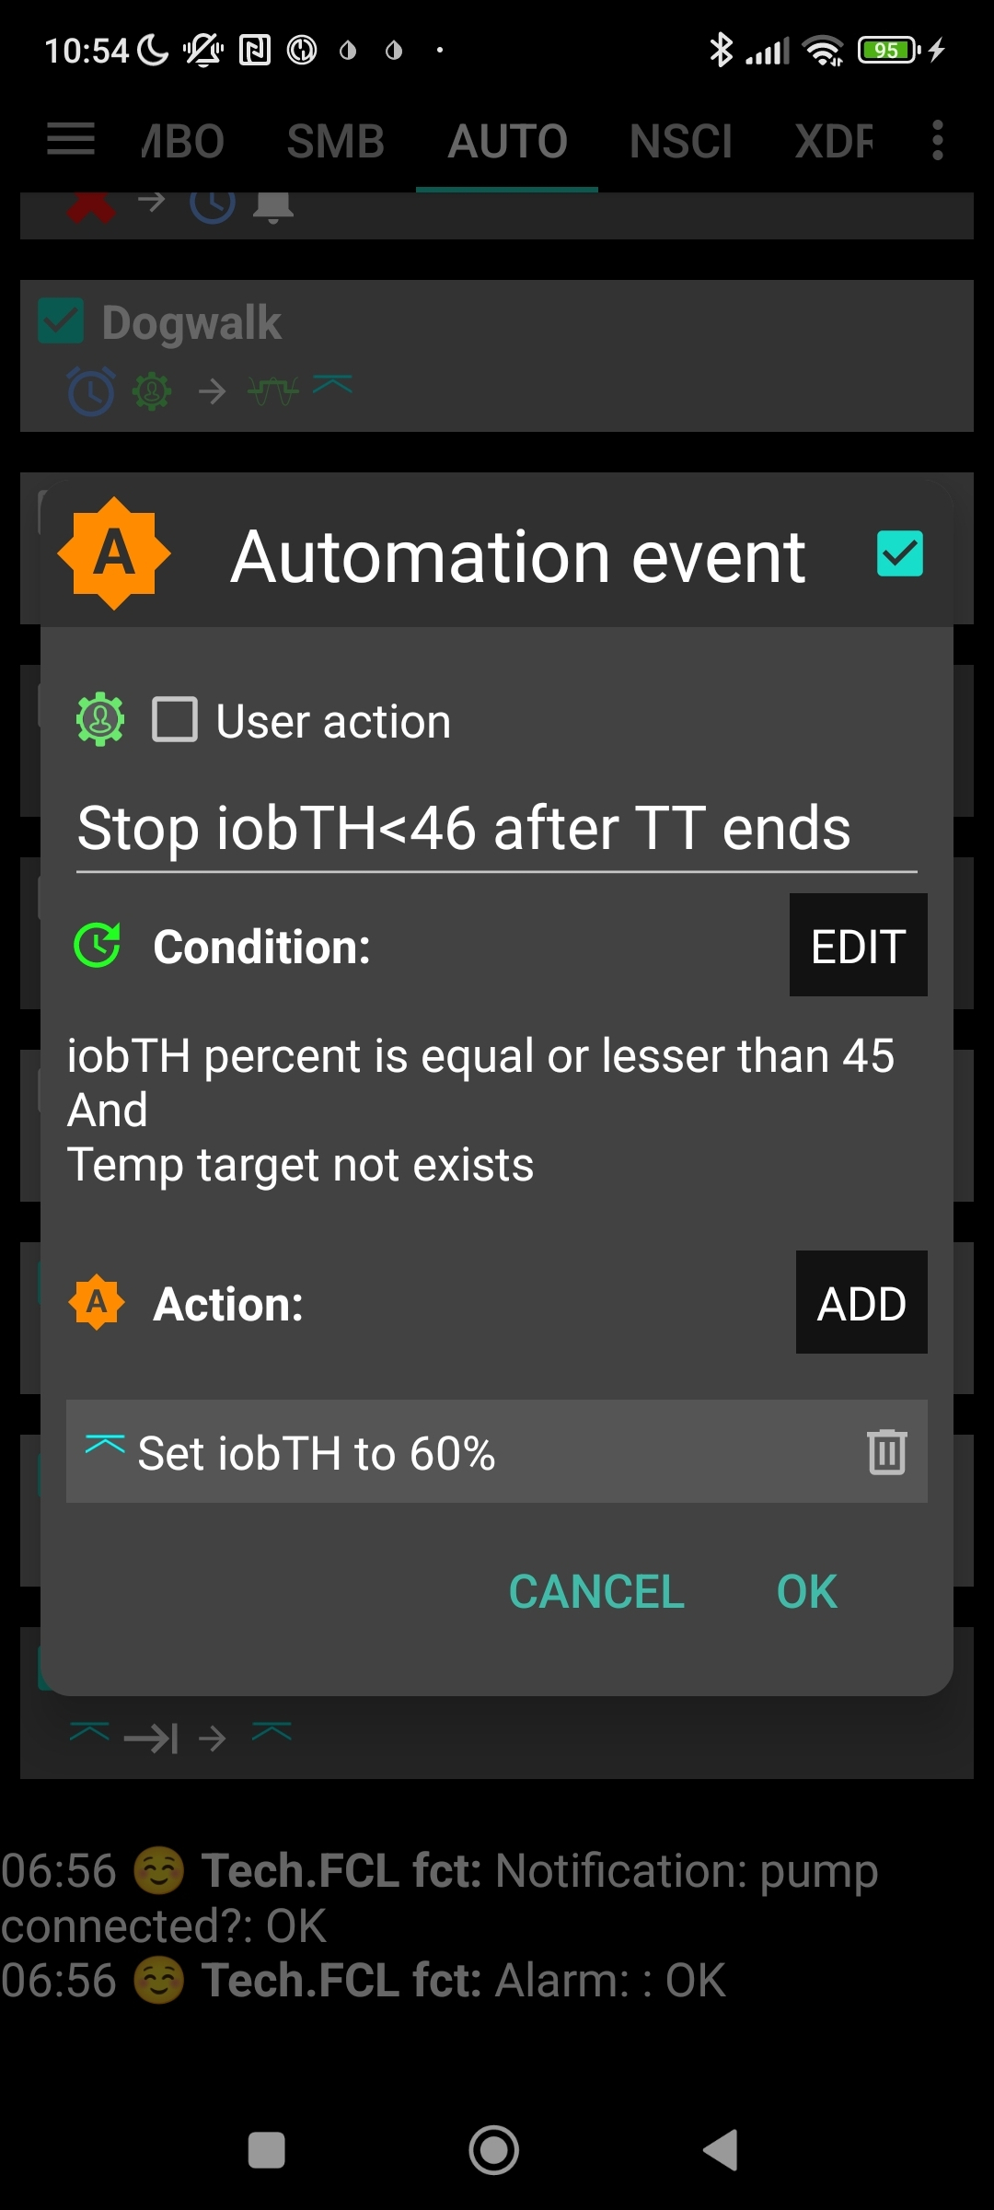
mation that must be active in tandem, that restores the prior set iobTH or bgAccel-ISF_weight again. Else, once your Automation sets in, it will forever shift this important parameter setting! If for instance you have several Automations that, in combination with a set elevated TT also set a lower iobTH: Don’t be fooled, the duration only applies to the TT. You need an extra Automation for all of them. I picked out the highest of the lowered iobTH values that these Automations can set (45_percent was the highest in my case), and then I can automatically restore to my prior 60% via this one:

Caution: Watch out for another potential stumbling block, because many Automations only work under the condition that no TT is already running.
As temp. changing iobTH is quite tricky to automate, it is the author’s preferred route to only indirectly modify it – see next section.

6.1.3 Dynamic iobTH: iobTH modulation via setting a temp. glucose target

In AAPS/Preferences, set “High TT raises sensitivity = TRUE”. Then, setting a temporary glucose target (TT), modulates iobTH the same way as it modulates sensitivity (ISF).
When. additionally. the exercise button is ON (lit yellow), iobTH gets reduced particularly strong, and ISF is particularly weakened (as desired for exercise). That effect is the stronger (ISF gets the weaker, iobTH the lower), the lower you set the half-basal exercise target for your exercise mode in AAPS/preferences/OpenAPS SMB:
The following table shows, for a profile target of 100 mg/dl, how the set …
- @ half_basal_exercise_target you set in AAPS/preferences/OpenAPS SMB…
Choose a low number if you later want a high dynamic range of sensitivity modulation Lower half-basal exercise target = lesser insulin delivered
- … and @ your current exercise TT that you set on the day you do the respective exercise, with an eye on how you wish sensitivity auto-adjusted…
Higher TT = lesser insulin delivered
… determine the effective sensitivity ratio. Note that:
- temp. basal = profile basal * sens.ratio
Example: At a half-basal_exercise_target of 120, setting a TT of 120 gives only half (0.5) of profile basal (hence the name of the parameter)
- temp.ISF = profile ISF / sens.ratio
- temp.iobTH = set iobTH * sens.ratio

Half basal ex.target | 180 | 150 | 120
TT | sens.ratio | sens.ratio | sens.ratio
100  100 = profile target | 1 | 1 | 1
120 | 0,8 | 0,71 | 0,5
140 | 0,67 | 0,56 | 0,33
160 | 0,57 | 0,45 | 0,25
180 | 0,50 | 0,38 | 0,20
The exact calculation for any combination of profile target, set TT, and half-basal_exercise_target is given in section 3.3
Rather than bothering with the math, you can just look into your SMB tab where your selected temporary settings put your iobTH (and modified ISF):
The valid “effective iobTH” can also be seen in the SMB tab, see example (for a TT=144 and exercise button clicked);
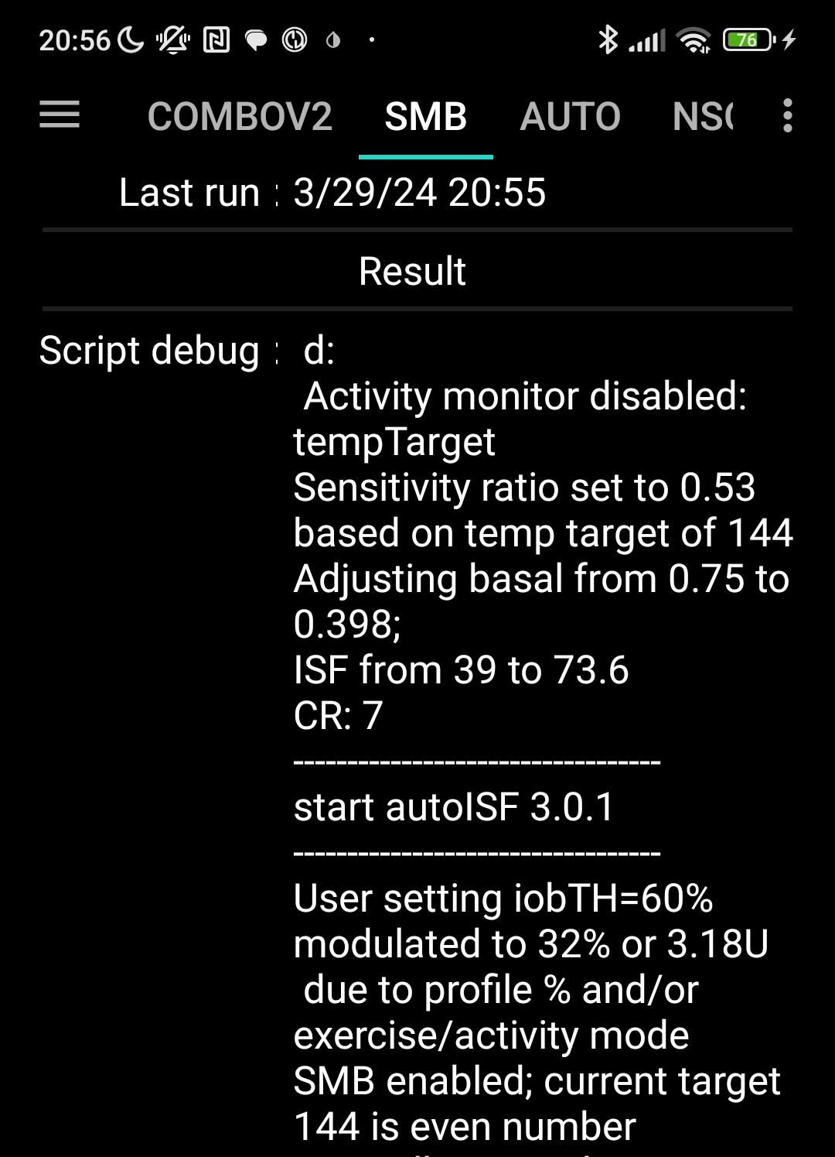

Same, with additionally 70% profile applied;
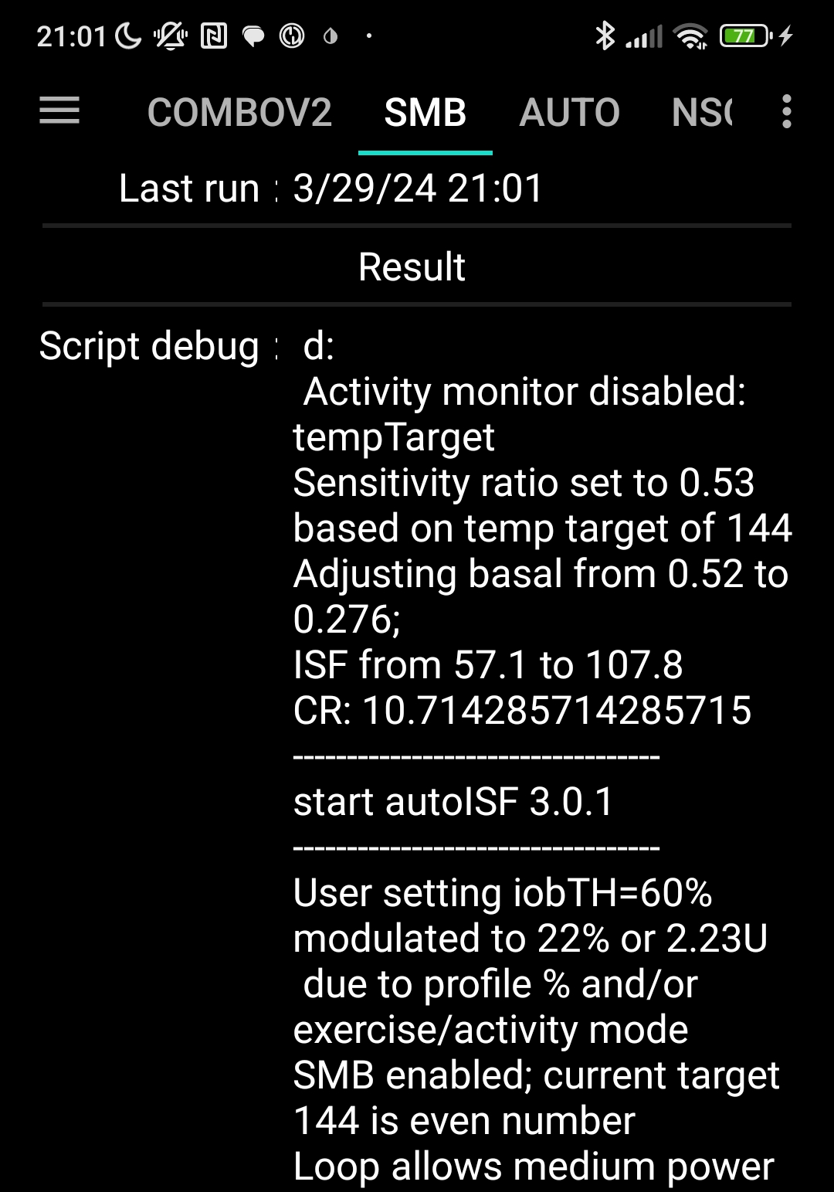

These examples show that, by just setting an exercise TT, the iobTH can get reduced to about half; and further to about 1/3, by additionally setting a typical exercise profile%.
This automatically ensures that SMBs cannot drive iob much over these modulated limits.
If you concurrently use the Emulator (see section 11) you need not look into the SMB tab, but could see more details (~ for the last hour, plus contributing …ISF_categories from autoISF), in tabular form, on your phone.

Try to determine good settings for the kinds of exercise that you frequently engage in.

Later, just press the grey DIY button, or the TT button, and make an exercise-related entry there (sections 6.2 or 6.3; case study 6.2). This will automatically switch the exercise button to yellow (ON), and it lowers basal and iobTH as (in your experience) suitable.

Note that
- setting a TT often shuts out other Automations. Choose the duration wisely (and also the sequence, in which all your Automations are listed).
(2) (assuming, you use the even/odd differentiation for SMB on/off:) Consciously decide whether you set an even or an odd numbered TT or target.
- Pick odd, if you do not want SMBs during exercise. (Despite you softened ISF, SMBs still might „attack“ a sports snack too strongly).
However, odd cannot be set too early, when your meal digestion still requires SMBs. Likewise, you might want the option for a few automatically delivered SMBs against unforeseen spikes (e.g. from excitement) also later. An Automation that switches, from odd to even, for a couple of minutes might sneak in a desired SMB or two .
However, you are probably out of luck because an already set odd (or any) TT would preclude such Automation from kicking in. Then you need to develop additional ideas, another detour, like to first define an Automation that briefly shuts your odd TT down.
- Working with an even TT can be preferable, notably of course if your exercise is one that can get you totally excited, with glucose spikes. While this mode generally does allow SMBs, the loop softens the ISF (by the sens.factor like in the table given above), and will temp. shut SMBs down, when iobTH (which also got lowered by the sens. factor) is exceeded.
Whether odd or even TT is better depends on the kinds of exercise you are doing, and probably depends on the protein and fat load of your meal and snacks, as well.

(3) Timing can be critical as to when you do this exercise announcement, especially relative to a preceding hi-carb meal. Then you want the reduced iobTH in place latest after you received the first SMB. See section 6.4 and case study 6.2
You always can look the effective iobTH up in the SMB tab (see screenshots given 2 pages earlier)..
In furture releases you might see the valid iobTH that your loop is working with also in your AAPS home screen, next to the current iob status.

You can use any of the above discussed methods, or also the one that now follows in section 6.2, to further tweak iobTH temporarily, should you see a need.

Also outside of exercise, setting an even TT + pressing the exercise button gives easy access to modulate iobTH (and, concurrently, aggressiveness re. applied effective ISF).
This could be used for instance for 45-60 minutes at low/medium carb snacks, as an alternative to shutting SMBs entirely off via odd TT. It could be set around meal start, or, ideally, after you felt the sting from the first big Lyumjev SMB …

6.2 Temporary % profile switch

A complementary measure you can take from the AAPS home screen is to set a reduced temp.% profile sensitivity.
This setting would multiply with the results in above table and further reduce basal and iobTH (whenever exercise button AND profile button both are yellow).
An example was already given with the 2nd screenshot, 2 pages earlier

Temp. reduction of basal will proportionally also reduce the max. allowed size of SMBs (which is two hours worth of basal x SMB_range_extention, see section 2.1)

Note that the time windows for doing this profile switch (which was the main ingredient of going into exercise in hybrid closed loop) can differ from your TT-related exercise settings. Using all available tools then allows a nearly surgical approach to what you want to achieve for and during your favorite exercise(s).
- Often the %profile modulation is used for several hours if not days to accommodate “long waved” sensitivity swings (See e.g. in case study 6.2).
- Instead, or even additionally, the percentage might be modified for just a couple of minutes, or for one special snack or meal duration, to “nudge” the proportionally modulated aggressiveness of the FCL (see section 5.2.3).

You can prepare yourself for anything you see coming up, or potentially coming up, in your daily life, so, from the comfort of your cockpit you get ready for it within just a second or two, doing a few „clicks“.

6.3 Managing exercise via Cockpit inputs

You may want to skip sections 6.3 and 6.4 because (green texts) mostly it is about suggested further features in future software updates

6.3.1 Basic Settings for Exercise

Coming from FCL with no TT set (both top fields, TT and exercise, are grey), you best prepare for an intended exercise by pressing the TT field of your AAPS main screen (your looping cockpit; presented in section 5.2).
There, you can freely select TT and duration.
Alternatively, you can press on one of 4 offered exercise presets. (Note: This, and many other – in this green color - described cockpit features are yet to be developed)

When you do either one, the exercise button in the top middle of your AAPS main screen should turn yellow (or just press on the exercise button, when a TT is set.)

6.3.2 „Dynamic“ exercise mode off = traditional AAPS exercise mode (YGY)

When the dynamic exercise mode is off, you still have the instruments for exercise management just as you always had it in the past = a combination of manually softened aggressiveness via setting a temp. %profile change, and orienting corrections towards an elevated TT.

By selecting an odd numbered TT you now have the additional option to shut SMBs temporarily off, too.

If improved cockpit is launched, the top part of the dialogue box looks about like this when the exercise field is grey:
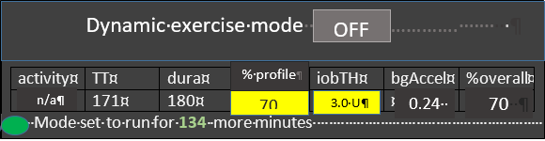
effect.sens.
70 %
% profile can be changed:
- either here => neighboring %profile button turns yellow too (with the % info on it); or
- under the %profile button; or
- it had already been changed using AAPS / Action / Profile switch
In all 3 cases, you see the number < 100 or >100 in the middle of above table, on a yellow colored field, too.
In this “YGY” mode, the % temp. set profile is the applied “effective sensitivity” (% ratio)

TT and duration can be entered or changed (= traditional mode to set exercise targets).

If there is a desire to try, for the remaining duration, a different iobTH or bgAccel_ISF-weight, this can be overridden in the table; field turns yellow, and the algorithm uses temp. iobTH and/or temp bgAccel_ISF_weight as modified in the exercise button (and reports this also in the SMB tab).
In the dialogue box pictured above, 70% profile was set for 3 hours, and the default iobTH of 60% * 10 U was cut by 50% down to 3.0 U.
The remaining duration shows below the table (in the example: 134 minutes and counting down).

The effective iobTH is given in the SMB tab. In later versions, the effective iobTH should show also in the AAPS home screen, next to the actual iob (e.g. „1.2 U < 3.0 U“)
TT and % profile will also show on the yellow labels of the neighboring %profile (left top of AAPS home screen) and TT (right side), respectively.

The middle (exercise) field remains grey because the automatic sensitivity tuning (that would use TT and half-basal exercise target) are off.

6.3.3 Dynamic exercise mode ON (GYY or YYY)

By pressing the yellow exercise button on the AAPS home screen, you have the option to switch the dynamic exercise mode ON, in which case the middle field/exercise button of your AAPS main screen will go from grey to yellow.

In a version update you could do your setting for the upcoming exercise under the dialogue box of the TT button
Then, when you look into the exercise button in the middle of your FCL cockpit the dynamic exercise mode will automatically be „ON“, and all entries made:
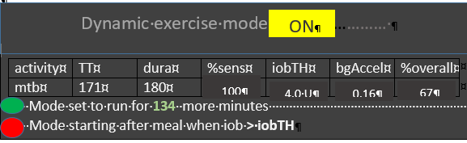
effect.sens.
67 %
The data for the kind of exercise (here mtb; could also be n/a or ?) are coming from prior selections made in the dialogue box of the neigboring TT field. There, as well as in this window here, the resulting iobTH and bgAccel_ISF_weight are shown. Also the overall aggressiveness (% overall insulin sensitivity factor) is calculated.
The middle field of the table in this dialogue box, % profile“ either picks up the % set under the %profile button, or an input can be made here, in the exercise button domain, which will:
- turn the neighboring %profile button on yellow and show that inputted % on it, too
- be multiplied with the result from the exercise mode settings per se, and change the effective sensitivity %, accordingly.
So, if this middle field of above table (dialogue box of exercise button) contains a figure other than 100, the input field becomes yellow, and you are operating with a combination of traditional PLUS new exercise mode (with all three top buttons of your FCL cockpit yellow). This maximally will soften aggressiveness, for which you get an idea by the last calculated figure.
The mode is either running already (for another 134 of the total 180 minute in the picture) as also the label on the neighboring yellow TT field will show 171 (134, and counting down),
Or (see at the red dot in picture above), it is scheduled to run, after insulination for a started meal surpasses iobTH (as in table).
Note that, when the TT expires or is changed, your overriding input (if you made any) is automatically erased, forgotten.

6.3.4 Dynamic exercise mode ON plus %profile change (YYY)

The middle field of the table in the dynamic exercise mode dialogue box (see above), % profile“ either picks up the % set under the %profile button, or an input can be made here, in the exercise button domain, which will:
- turn the neighboring %profile button on yellow and show that inputted % on it, too
- be multiplied with the result from the exercise mode settings per se, and change the % overall, accordingly.
So, if this middle field of above table (dialogue box of exercise button) contains a figure other than 100, input field becomes yellow, and you are operating with a combination of traditional plus new exercise mode (with all three top buttons of your FCL cockpit yellow). This maximally will soften aggressiveness, for which you get an idea by the last calculated figure.
Maximal softening happens only when >100% profile. A <100% profile is not used for exercise typically, and would counter-act the softening from the elevated TT.
It is advisable to find good settings primarily within the dynamic exercise mode. Use profile switches only complementary as needed. notably to provide for other, „longer waved“, health or hormonal situations.

Note that you can make use of the exercise button at any time for easy tweaking..
…… only if a TT is set …
- yellow -> off/grey = increase
- grey -> on/yellow = decrease
..the aggressiveness, without changing (and changing back) settings.

6.4 Option to pre-set for 4 kinds of exercise or meals (for 1 button operation)

You may want to skip section 6.4 because (green texts) mostly it is about suggested further features in future software updates

6.4.1 iob_threshold_percent

In AAPS preferences/OpenAPS SMB/autoISF settings / Full Loop Settings, the default iob_threshold_percent used for the normal meal spectrum is defined.
In an updated later autoISF version you might be able to diffentiate there for up to 4 meal clusters (see next section)

6.4.2 Pre-settings for (up to) 4 kinds of exercise:

In AAPS preferences/OpenAPS SMB/autoISF settings / Full Loop Settings: follows next input fields for pre-settings you can define for (up to) 4 kinds of exercise:
The following table gives an example of settings you may find well-suited for 4 of your favourite exercises
#1-4 | give name (max 3 characters) | duration for TT ( (min) | TT (AC) (mg/dl) | % profile | iobTH | bgAcce:weight | Approx % ins reduct.
1 | wlk | 60 | 111 | 100
2 | grd | 120 | 131 | 90
3 | bik | 300 | 151 | 90
4 | mtb | 180 | 171 | 70
Input fields (during tuning phase to determine good settings) are only the columns 2-5. The last 3 columns will be calculated from TT and %profile inputs, using also the half-basal exercise target and the default weight setting. In this setting.
The last is only an approximation to get a feel for a reasonable setting of the other parameters.
Here in preferences they should never be overridden, but TT or % profile should be adjusted to reach desired result when tuning for FCL.
Likewise, you find tables to make pre-settings for meals and for hypo treatments:

6.4.3 Pre-settings for (up to) 4 kinds of meals:

In AAPS preferences/OpenAPS SMB/autoISF settings / Full Loop Settings: follows next: Input fields for pre-settings you can define for (up to) 4 kinds of meals. For instance:
TT# 1-4 | give name (3 letters) | TT (Eating Soon) (mg/dl)e | Duration for TT (min) | iobTH (0---130% and < iobMAX) | bgAcce factor 200…0%
1 | hiC | 72 | 120 | 110 | 110
2 | loC | 74 | 180 | 67 | 67
3 | piz | 76 | 300 | 100 | 100
4 | snk | 78 | 60 | 100 | 50

Input fields (during tuning phase to determine good settings) are all columns
Difference in TT is fairly unimportant (unless you do not give a name and memorize the set TT number instead, for which meal type it codes.
Logic why not having a % profile column here: %profile switch should be set extra, potentially for another time period (e.g. „reserved“ for periods of exercise, or for entire days of altered insulin sensitivity, for instance due to illness, fasting, extensive sports week.)
6.4.4 Pre-settings for (up to) 4 kinds of Hypo treatment:

In AAPS preferences/OpenAPS SMB/autoISF settings / Full Loop Settings: follows next: Input fields for pre-settings you can define for (up to) 4 kinds of HYPO treatment. Example:
TT (ES) (mg/dl) | give name (3 letters) | TT (AC) (mg/dl) | Duration for TT (AC) (min) | bgTH  (mg/dl)
1 | Hy1 | 131 | 55 | none
2 | Hy2 | 131 | 55 | 200

Input fields (during tuning phase to determine good settings) are all columns, 2-5.
Choosing an odd-numbered TT is recommended as it can shut-out SMBs (with the appropriate setting in preferences/Open APS SMB/autoISF settings/smb_delivery settings/“enable alternatiuve activation…“.

Those of us who tend to over-treat hypos may prefer to set Hy2 (unless for night snacks-> Hy1): Reverting to standard loop aggressiveness with SMBs after/if a certain bg level („threshold“, similar to our iobTH for meals) is surpassed, and we want our loop to react again with SMBs before the set duration expires.

6.5 Mastering Exercise after a Meal

In Hybrid Closed Loop, we gave less insulin at meals (a reduced bolus) before exercise.
Since we now get our meal insulin automatically from the loop, we would have to at least somehow tell it that exercise follows this time.
Simply setting an exercise profile before the meal would make our full closed loop too weak in the "treatment" of the first glucose rise. What we want is, to get our (already, compared to HCL, delayed) meal insulin delivered as fast as possible by SMBs. It just should be capped at the desired iob reduction.

6.5.1 Manual mode requires 2 user interventions

What we can do, is (1) reduce the iobTH (via the _% setting, e.g. by one third).
- In the example we were using, this would mean to reduce by 2 U to iobTH* = 4U.
- Do that estimate for your data, and think back how you did bolus reduction in hybrid closed loop before same exercise.
- Likewise, you can use your profile ISF, e.g. 30 mg/dl/U and „translate“ by how much ( 2U * 30 mg/dl/U = 60 mg/dl) this „pulls you away from going into a hypo“.
- Using your IC (e.g. 8g/U) you can also translate the iobTH reduction (2 U) into a „snack equivalent“ (2U * 8 g/U = 16 g) that you „replace“ by thinking ahead and „budgeting“ for some exercise with your iobTH modulation.
In this senario, our loop delivers SMB insulin as fast as always, only that when the last SMB has passed the iobTH, the loop only has elevated %TBR to work with, meaning it cannot raise iob by much any longer. This provides an elevated glucose level on which we enter exercise, and saves us hypo danger or snack need (as calculated in above examples).

After this reduced iobTH is reached (or up to 30% exceeded by the last SMB, up to 20% @ even TT>100 mg/dl)), step (2) must follow = an increased exercise bg target is set (see section 6.2).

The problem with this approach is that it requires two user interventions, first setting the lower iobTH%, and later (and this in a time-critical manner, after iobTH is exceeded), to input an exercise TT, or to activate a related setting.
To eliminate this problem, the following refined solutions are suggested:

6.5.2 DIY cockpit: Using pre-set meal / exercise settings from a User action Automation

The „DIY cockpit“ user interface allows a one-step setting for meal + exercise that can be selected in time-uncritical fashion, any time before the meal starts.
A detailed example is given in case study 6.2:
A sequence of 3 Automations must be set up, of which only the first one must be manually triggered, in just one time-uncritical key stroke from the AAPS home screen.
The others are activated automatically, when the respective Conditions are met.

Automation #1 provides, for a meal that precedes exercise, the full loop aggressiveness, but makes sure that this aggressiveness stops immediately after a (reduced) iobTH is exceeded. The reduced iobTH ensures that not too much insulin is on bord for exercise after the meal. Also it provides an elevated bg level at (re-)start of exercise.

In this Automation, the box “User action” should be permanently ticked. This will automatically provide a grey button on the bottom of the AAPS home screen (“DIY cockpit”) that can be freely named (= headline of Automation #1).
For exercise that is not done frequently, I choose to get rid of that cockpit button by disabling the Automation fully, in my list of Automations… until the evening before e.g. a bike tour, when I will want to have my cockpit give me the optional button again.(See case study 6.2)

When the reduced iobTH is exceeded, two things need to be provided :
- a milder running FCL (reduced exercise %profile, after the meal rise had been managed based on 100% profile boosted further by bgAccel_ISF driven full loop aggressiveness) => Automation #2 sets e.g. 70% profile and ends TT
- setting an exercise TT (not possible with Automation #2. But after it terminated the TT, an Automation #3 can immediately follow, and set the desired exercise TT=125 (which implies the exercise mode
Note that Automations 2 and 3 are fully automatic, no User action is involved. See case study 6.2 for an example

Should, during the exercise, a need arise to modulate the loop aggressiveness (iobTH, effective ISF), this can be done within 1-2 seconds, also right from the AAPS home screen („FCL cockpit“), by setting a higher or lower temp. %profile, and/or by setting a higher or lower temp. exerciseTT.
To make the loop temporarily act a bit more aggressive, switching the exercise button OFF (from yellow to grey) could also be considered

Defining User action - Automations to build your FCL cockpit

If you want to develop your DIY User Interface, make sure you define suitable settings that reflect your personal insulin sensitivity and data patterns.

Caution: As mentioned in other places, Automations can be tricky as to whether they actually will ever work, because the loop goes through the exact sequence of all your active Automations, and might be switched into a direction that no longer is compatible with the conditions that must be a given, for the Automation you think that should kick in.

To have a clean AAPS home screen (and also to prevent unnecessary/accidential activation by kids playing around with offered buttons), define reasonable time windows for each of your shelved special routines, or keep them entirely dormant (de-activated) in the list of all your Automations, and activate them only for/on the day when you think you might need them

6.5.3 Improved cockpit: Using pre-set meal / exercise combination from TT dialogue box
The improved „FCL cockpit“ User Interface (when available) also allows a one-step setting for meal + exercise that can be selected in time-uncritical fashion, any time before the meal starts.
It manages the meal with an appropriately reduced iobTH, and is programmed to automatically activate the exercise settings when iobTH is exceeded:

If in addition to meal, one of the 4 pre-programmed exercises is also selected from the bottom of the TT dialogue box, (for example, in case of biking after a hi carb lunch, hiC + bik, see section 5.3.3.1.) then meal gets superseded /overridden with condition „duration = until when iobTH is first time exceeded“. Plus, that is the other important point, the activity-related reduced iobTH is taken over for the meal, too.

All this happens from the AAPS home screen and associated dialogue box from the TT field there.
Actual valid settings can at any time point be seen in the AAPS home screen (see section 5.3.3.1 on extra data fields, above).
When your FCL is in this meal + exercise mode, you first see at the TT field (section 5.3.3.1) of your AAPS main screen:
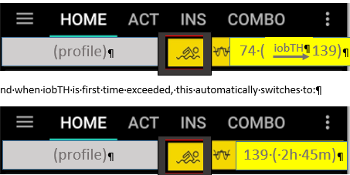
… and when iobTH is the first time exceeded, this automatically switches to:

That 1-step setting can either be freely done according to section 6.2
Or you can just press one of your frequent meal and frequent exercise „codes“, as described in sections 6.3.2 and 6.3.3
Example: For mountain biking after pizza lunch press two buttons, piz and mtb, in the dialogue box of your AAPS home screen‘s TT field. That’s all (…after, one time, you figured out what settings suit that scenario, and you put it into /preferences, see sections 6.3.2 and 6.3.3).

6.5.4 Laissez-faire alternative

You could also just use an exercise setting and accept a reduced loop aggressiveness already before meal start. You would go a bit higher in your glucose peak. As, in principle, a higher glucose level is desirable for starting exercise, this can be a viable route, too.

This depends on your meal’s carb load also, and should be viable if you do the often recommended protein-rich meal before exercise.

Note that making the exercise setting after meal start is problematic in case the first SMBs already exceeded the iob you see as limit for starting your exercise (which is not the limit for the meal per se).

6.6 Activity Monitor

An optional feature for times without serious exercise, but still suspected effects on insulin sensitivity (max +20% to minus 30%) is the activity monitor.

It can be generally activated under /preferences/OpenAPS SMB/Activity modifies sensitivity)
If the user
- has scaling factors set there (in preferences/OpenAPS SMB/Activity modifies sensitivity)
- has no TT running
- (and, regarding nighttime: did not opt for „ignore_inactivity_overnight“)
then AAPS automatically modulates for sensitivity changes based on movement intensity for the last minutes to 1 hour time frame.

Personalized tuning of the two scaling factors is necessary in your FCL set-up phase. For details see section 3.4.( Monitor)
The Activity Monitor can also be used (overridden/ used for tuning the scaling factors) from a dialogue box (if already launched) coming up from the exercise button (top middle of AAPS home screen).

Note that Activity Monitor only works if no exercise (or other) TT is active (which would influence insulin sensitivity ratio much stronger than the tweaking done by the Activity Monitor, for slighter everyday effects).
In this dialogue box (connected in a future update with the exercise button), the two scaling parameters (set as default by the user during initial set-up in preferences) are displayed, and can be temp. over written. (These settings will expire and revert to default as set in /preferences, whenever the Activity Monitor closes (goes auto-off, or is pushed off)).
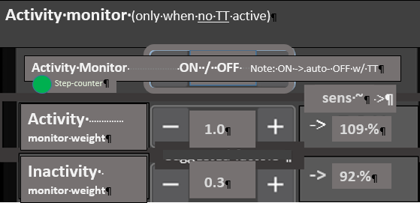
The resulting sensitivity effect is the roughly expected effect of requiring >100% insulin if moving around a bit (activity), or needing a lesser %age when being very stationary.
It is displayed in the right side column of the dialogue box (if already launched) to give the user a feeling for the expected effects from her/his „weight“ inputs.

The exact impact is calculated by the loop and shown on top of the autoISF results in the SMB tab (every 5 minutes).

